***SHIFT REDUCE PARSING***

***Ayush Jindal***

***RA1911003010308***

***SOURCE CODE:***

*#include<iostream>*

*#include<string.h>*

*using namespace std;*

*struct prodn*

*{*

*char p1[10];*

*char p2[10];*

*};*

*int main()*

*{*

*char input[20],stack[50],temp[50],ch[2],*t1,*t2,*t;*

*int i,j,s1,s2,s,count=0;*

*struct prodn p[10];*

*FILE *fp=fopen("input.txt","r");*

*stack[0]='\0';*

*cout<<"Enter the Input String:\n";*

*cin>>input;*

*while(!feof(fp))*

*{*

*fscanf(fp,"%s\n",temp);*

*t1=strtok(temp,"->");*

*t2=strtok(NULL,"->");*

*strcpy(p[count].p1,t1);*

*strcpy(p[count].p2,t2);*

*count++;*

*}*

*i=0;*

*while(1)*

*{*

*if(i<strlen(input))*

*{*

*ch[0]=input[i];*

*ch[1]='\0';*

*i++;*

*strcat(stack,ch);*

*cout<<"\n"<<stack;*

*}*

*for(j=0;j<count;j++)*

*{*

*t=strstr(stack,p[j].p2);*

*if(t!=NULL)*

*{*

*s1=strlen(stack);*

*s2=strlen(t);*

*s=s1-s2;*

*stack[s]='\0';*

*strcat(stack,p[j].p1);*

*cout<<"\n"<<stack;*

*j=-1;*

*}*

*}*

*if(strcmp(stack,"E")==0&&i==strlen(input))*

*{*

***cout<<"\n\nAccepted";***

***break;***

***}***

***if(i==strlen(input))***

***{***

***cout<<"\n\nNot Accepted";***

***break;***

***}***

***}***

***return 0;***

***}***

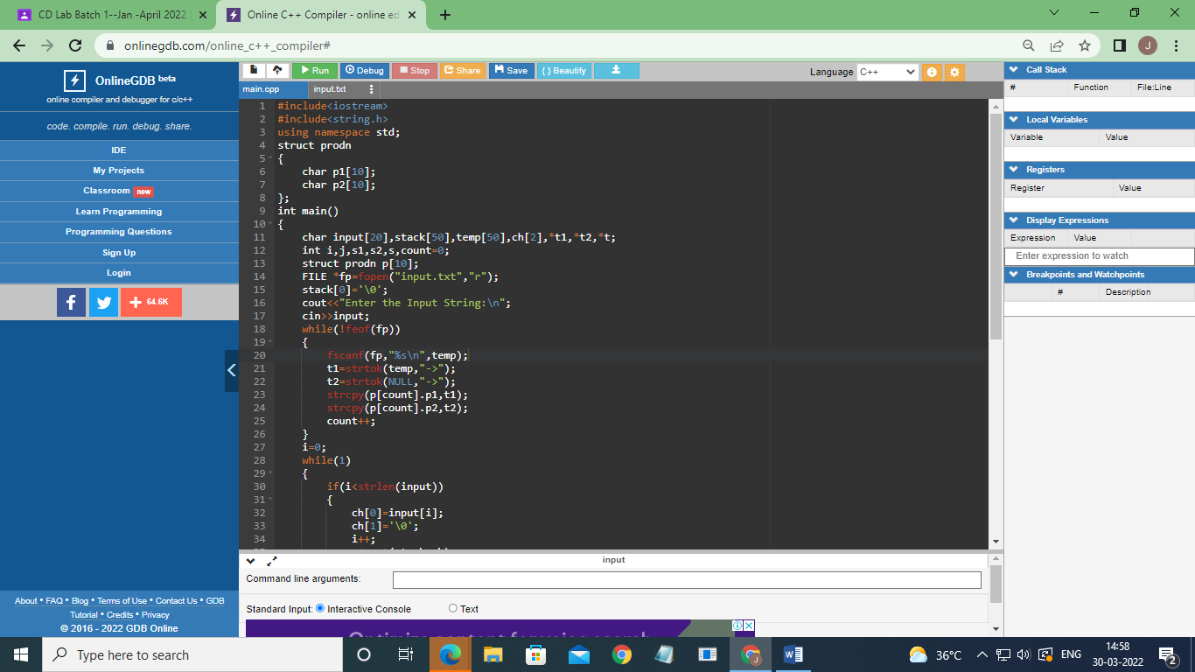

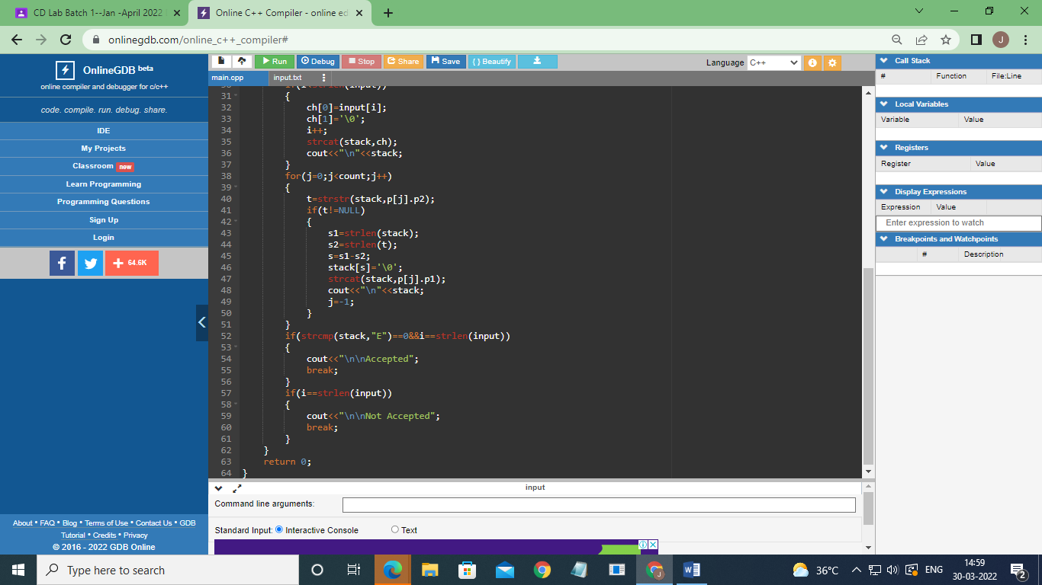

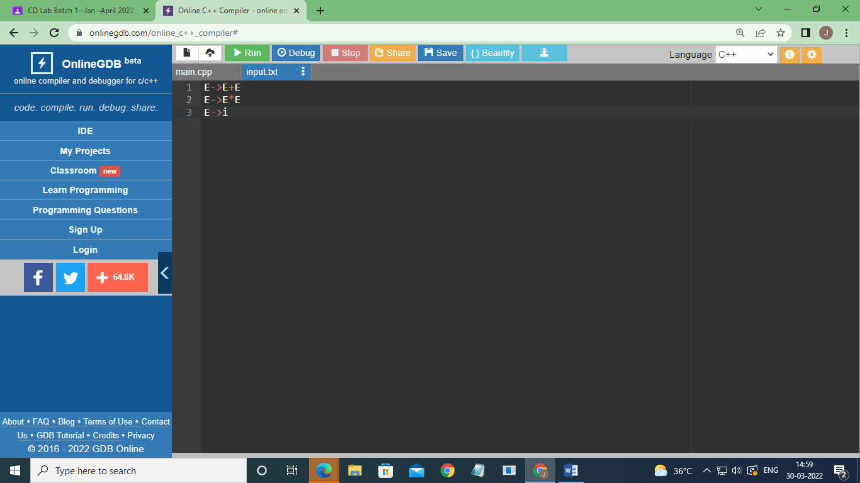

***OUTPUT:***

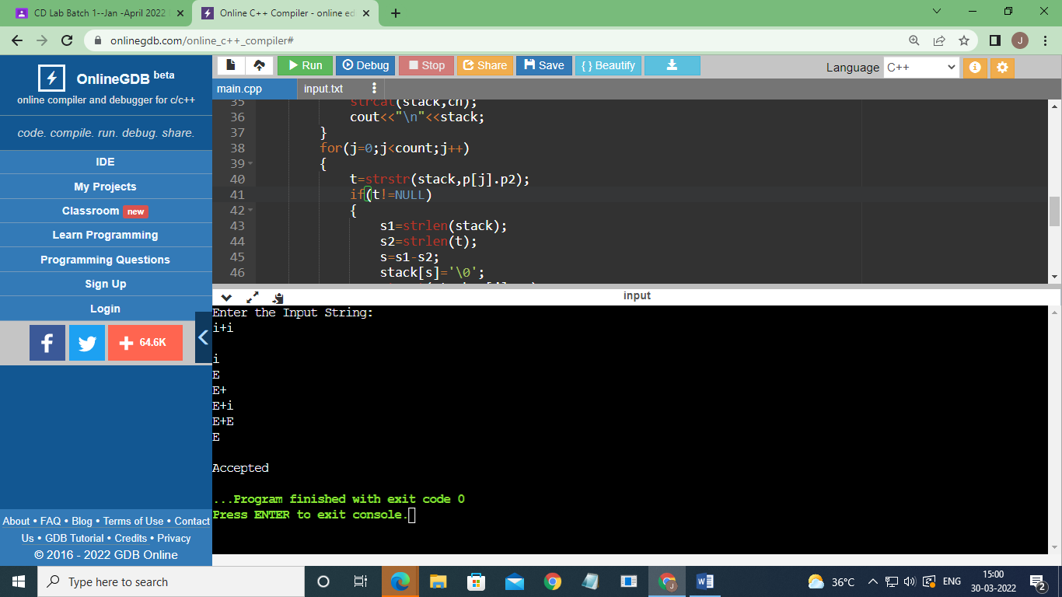

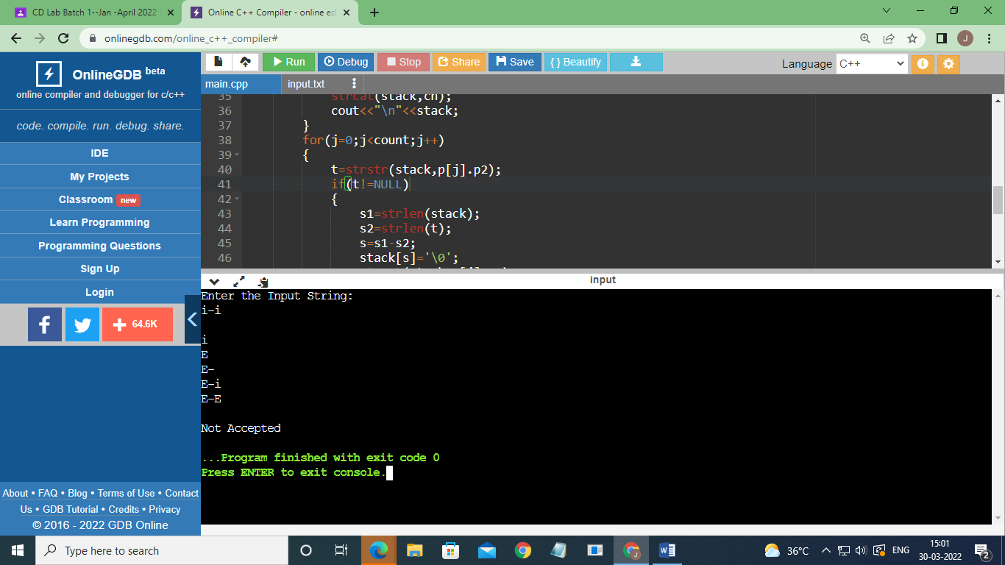

***RESULT:***

*Implementation of shift reduce parsing was done successfully.*